**Architecture Diagram:**

The diagram is also available as a photo in the main git folder.

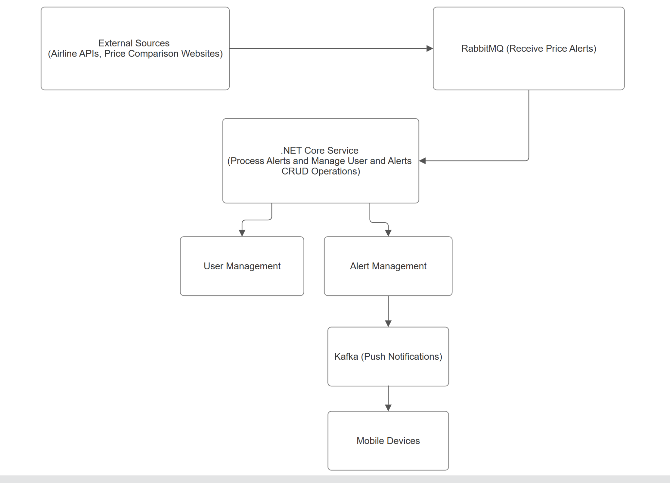

**Data Structures**:

**External source and RabbitMQ messages**:

{

"flightId": "Guid",

"flightSource": "string",

"flightDestination": "string",

"price": "decimal",

"timestamp": "datetime"

}

**User Management**:

public class User

{

public int UserId { get; set; }

public string Name { get; set; }

public string Email { get; set; }

public string PhoneNumber { get; set; }

}

**Alert Management:**

public class Alert

{

public int AlertId { get; set; }

public int UserId { get; set; }

public string FlightSource { get; set; }

public string FlightDestination { get; set; }

public decimal PriceThreshold { get; set; }

public bool IsActive { get; set; }

}

**Kafka push notifications:**

{

"userId": "int",

"flightId": "string",

"flightSource": "string",

"flightDestination": "string",

"price": "decimal",

"timestamp": "datetime"

}

**Data Flow:**

**Receiving Price Alerts:**

1. The system receives flight price information from external sources to RabbitMQ.
2. RabbitMQ messages contain the flight details and price.

**Manage Alerts:**

1. The .NET Core service consumes messages from RabbitMQ.
2. The service processes these messages and checks if any user's alert conditions match to the flight alert details and price.
3. The service manages CRUD operations for users and alerts.
4. By managing CRUD for alerts, users can create several flight alerts in the client mobile phone notifications settings, with the flight alert details that they are interested in, like flight source, flight destination and flight price threshold.

**Sending Push Notifications:**

1. When a price that interests users is detected, the .NET Core service sends a message to Push notification service.
2. The push notification service messages are consumed within the users mobile phones.